# 

# Noodlebox

Noodlebox is a self-contained music sequencer which can control voltages (CV), gate pulses and MIDI data.

Noodlebox is intended for jamming and creative experimentation within a loop based approach. U

# General

Noodlebox has many functions but quite a simple control panel. We have tried to avoid excessive menu diving by making use of button combinations to access functions. Most functions are accessed using eight buttons and a single knob.

A click means to press and immediately release a single button

A key combo of keys A+B means that key A is held down and key B is pressed

# A First Play

Power up the Noodlebox by plugging in the power supply and holding the ON button for 2-3 seconds.

Turn it off again by pushing the OFF button. This is the correct way to shut down the Noodlebox; it allows the current state of your session to be saved so that you can be back where you left off next time you power up. If you just pull the plug you will lose your session state.

TIP: If you really don’t care about restoring your session, just hold the CV button next time you power up. Holding CV when you turn the Noodlebox on means it starts with a clear session.



When you power up Noodlebox with a new session, you will see a screen like this. We call this a **page**

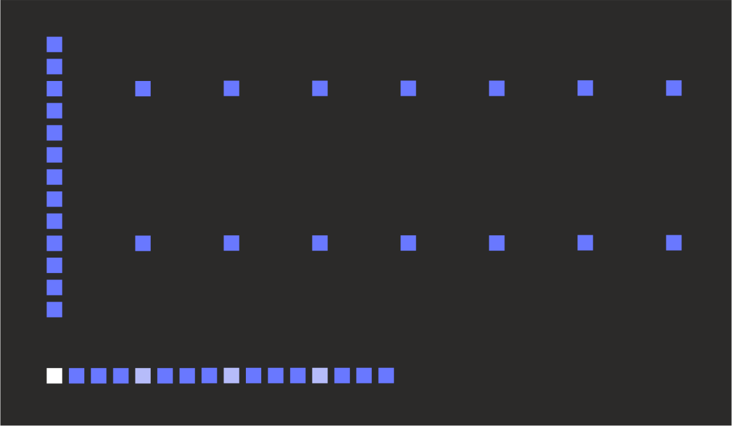

The page has 32 columns and 16 rows. Each column represents a single **step** in a musical pattern which can contain up to 32 steps. You can see all 32 steps on the page at the same time

The bar along the bottom row defines the **loop window**. While the page has 32 steps, fewer than this number may be active for being played. When we start a session, the default loop window is the first 16 steps, however the loop window can be set to any number of continuous steps and can play in either direction.

Every fourth step along the loop window bar is shown with medium brightness. The active step (the one which is playing) is indicated on the loop ruler in full brightness. Initially this is the first one.

The vertical bar at the left margin of the display is the **cursor**, which we use for the various editing functions. Turn the encoder knob and you’ll see you can move the cursor from left to right.

The top 13 rows of the display (the height of the cursor) is where we will enter the notes of our musical sequence. The two horizontal dotted lines that are already there are part of a grid showing the “C” notes at the start of each octave. These are to help you find your way around!

So let’s enter a note… move the cursor into the middle of the loop window, hold down the CV button and turn the encoder. A bright point appears along the cursor (this is the note we added) together with a text box showing the name of the note (e.g. “A2” – the A note in octave 2). By keeping the CV button pressed and turning the encoder, we can set the note to any pitch we like (see how the screen scrolls up and down)

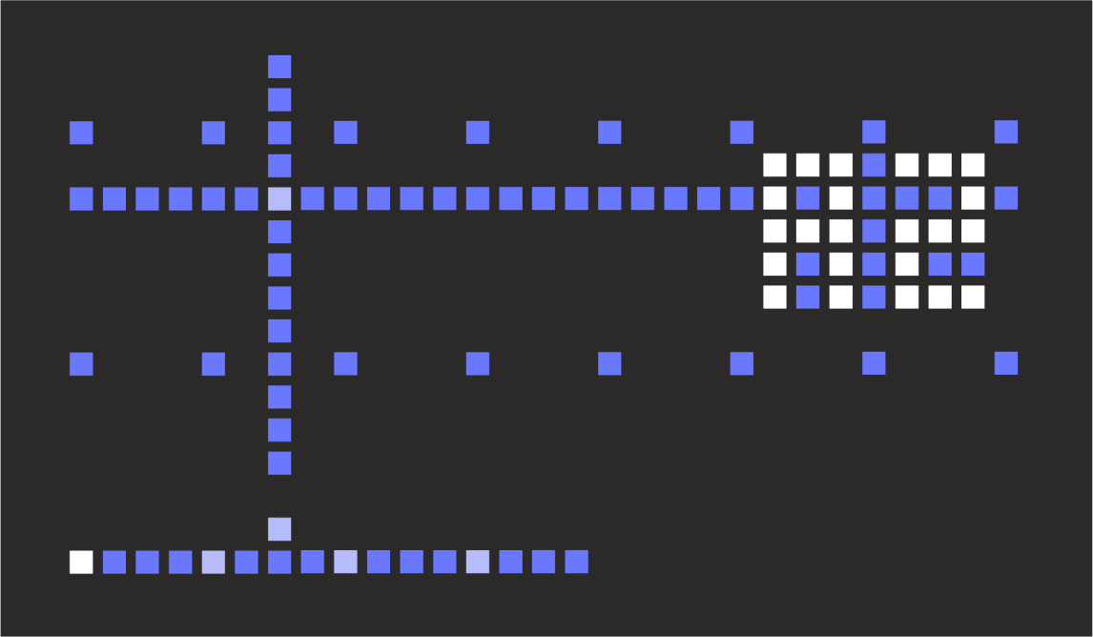

When we release the CV button, the note has been set. A new point has also been added at the bottom of the screen – this is a trigger point, which indicates we’ll send a gate pulse to the gate output.

We also now have a horizontal line spanning the whole display. This represents the control voltage (CV) output. Since we have only one note defined, the CV output will send the pitch CV for this note continuously (Pitch CV never “turns off”, it must always be set to something!)

Now add another point… move the cursor to a new position and hold CV and turn the encoder. Initially the note picks up the CV value in that column and we can then drag it around

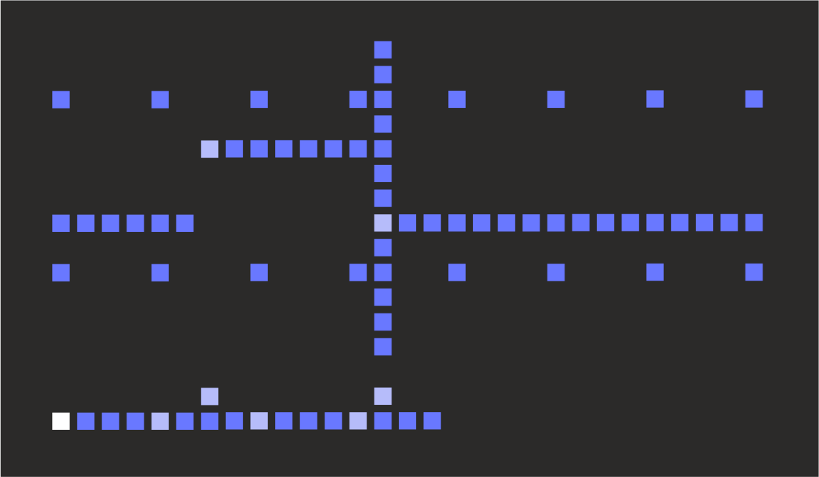

So here we have a sequence of A2 and E1. There are two trigger points and the pitch CV always follows the last note value we entered. These values are shown in a brighter colour to show that they are **data points** we created ourselves, where the other points are dimmer to show they are **fill points**. We’ll use these names going forward, since these points are not always note pitches (they can be modulation voltages etc.)

Now lets play this sequence… press the RUN button (above the encoder). Now we see the active step marker count along the loop window bar (and return back to the start when it reaches the end). The current data or fill point and trigger point (if any) are also shown in the brighter colour.

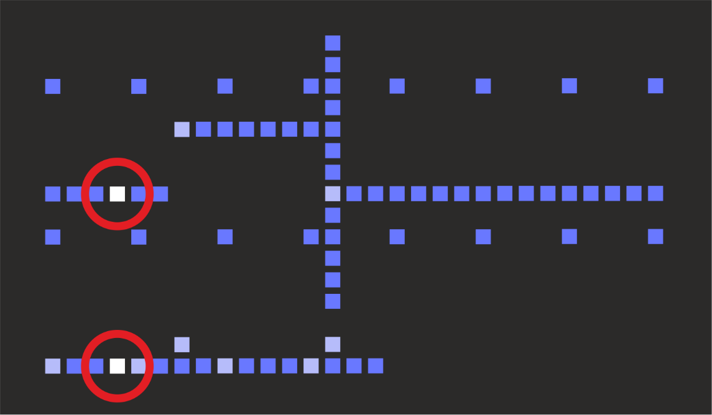

Patch up GATE 1 and CV A to your synth to hear it play! If you want to use the MIDI output, click the LAYER button to show the menu. Use the encoder to scroll down to the entry MID NONE and hold the CV button while turning the encoder to select MID NOTE. Now change the MIDI channel if needed. Press the LAYER button to return to the main display.

# Basic Editing Actions

So above we saw how to create new data points. Lets briefly look at some basic actions for editing the pattern on a page and controlling its playback

* To **change** an existing data point, simply move the cursor to that column and hold down the CV buttons. Turn the encoder to change the value of the point
* To **clone a single data point** into one or more new steps, move the cursor over it and hold the CLONE button, then move the encoder to paste the data point into adjacent steps.
* To **clone a series of data points**, press and release CLONE (a bright point, the **copy source marker,** appears in the lower part of the display) and move the cursor to the new location, hold CLONE and turn the encoder. Adjacent data points are copied from the source location to the destination one.
* To **clear** a data point, move the cursor over it and click the CLEAR button. To clear multiple data points, hold the CLEAR button and move the cursor over the points to be cleared. You cannot clear fill points, but when the last data point is cleared, all the fill points will be set to zero.
* To **change the loop window**, move the cursor to the new start position and hold down LOOP. Now turn the encoder until the cursor is at the new end position (a text box will show how many steps you have selected). The new loop window does replace the old one until you release the LOOP button.
* To **play a pattern in reverse**, simply select the loop window from right to left.
* To **make playback jump immediately to the start of the loop window**, just click the LOOP button.

# Shifted Actions

We’ve seen how different Noodlebox actions can be selected by clicking buttons or by holding buttons while turning the encoder.

Noodlebox has a large number of actions that are selected by holding down one button while pressing another (like holding a SHIFT key on a computer keyboard). However, on Noodlebox almost all the buttons can be used as a “shift” key!

Lets start with some basic ones

* **To move the whole pattern to the left or right**, hold down CV, then hold CLEAR. The text “HORZ” appears to indicate a horizontal move. Turn the encoder to action the move.
* **To move the whole pattern up or down**, hold down CV, then hold RAND. The text “VERT” appears to indicate a vertical move. Turn the encoder to action the move

# Editing Triggers

We saw previously how a trigger appears when we enter a data point, however we do have a lot more control over this behaviour

* Clicking the GATE button will **toggle the trigger at the cursor position**. You can easily remove the triggers added with data points, or enter new ones
* Holding the GATE button while turning the encoder allows the trigger to be changed between three states; Off, tied (dim) and trigger (medium brightness). A tie has the effect of **extending the previous step’s gate without a new trigger**. Typically this would be used to hold the synth VCA open without retriggering the envelope.

As we’ll see shortly, Noodlebox has several different modes in which we can edit pages, and note pitch is just one of them. In other modes, triggers are not automatically created for data points.

# Layers

A Noodlebox session is made of four **layers**. Each layer may be used like a self-contained step sequencer, with its own pair of CV/gate outputs. All layers are clock synced to each other, but otherwise can be used quite separately.

Each layer can have up to four **pages**. A page is what you see on the Noodlebox screen and it contains up to 32 **steps**. Pages within a layer can be selected individually for editing and playback, or they can play in consecutive order (allowing you to make sequences up to 128 steps) or you can arrange them to play in a specific order.

Each step has a musical value corresponding to its vertical position. This value can be a specific note pitch or generic modulation value and can be mapped to a voltage or to MIDI data. However

A CV value is always present for every one of the 32 steps on any page. Some of these values are real data entered by the user, which we’ll refer to as **data points**. The other values are **fill points** which are added automatically to steps which contain no user-entered data. These fill points are shown in a dimmer colour than the data points.

Fill points can be generated in the following ways

* **Pad** – Each data point is padded out with fill points of the same value, until the next data point.
* **Interpolated** – Data points are joined by diagonal lines of fill points
* **Off** – All fill points have a value of 0

Each step contains both CV and gate information. The CV component always has a value between 0 and 127. How this is displayed and edited and how it is mapped to the actual output voltage depends on other parameters that are described below.

Each layer has an **edit mode** determines how steps are displayed and edited within the page

* **Pitch** – step values are presented as musical notes (e.g. C#2) based on the MIDI note equivalent of the data value. The display allows editing based on chromatic scale (all notes are visible and one octave takes 11 display lines) or to the selected musical scale (notes are force to scale points for viewing a one octave takes 7 display lines)
* **Modulation** – step values are presented numerically (e.g. 001) and the entire 0-127 range is visible on the display (so a single display line covers multiple values)
* **Offset** – step values are presented numerically from -63 to +63

Changing between editing modes will also set some default settings

When the sequencer is running, each layer outputs CV and gate information on its own CV and gate socket.

In addition, a layer can also provide CV input to the next layer (in numeric order) via the next layer’s **mix** setting. This mixing can happen in one of the following ways

* **None** – The previous layer output CV is not used
* **Add** – the CV output from the previous layer is added to this layer (prior to scale quantization)
* **Mask** – The layer outputs voltage information from the previous layer, with the exception of data points (not fill points) which are played, ‘masking’ the data at that point.
* **Both** – Rather like the Mask mode, but when a data point is present the CV output from the data point is added to the CV from the previous layer. Otherwise the previous layer CV is played unchanged

Mix mode is not available for layer 1 since there is no previous layer to provide input.

A layer can also be configured to send MIDI note or controller information

Pitch Layers send MIDI notes

# Gates

Each step has the following kinds of gate information attached to it

* **Gate** - these are points that create a positive edge on the gate output associated with the layer. If the gate is already open, it will quickly close and reopen at a trigger point (i.e. retrigger action). A per-layer setting allows gates to have a fixed duration (as a short trigger pulse or a percentage of full step time) or to be held open until the next gate.
* **Tie** – tie points can be used to hold a gate open for the full duration of a step without creating a new trigger (assuming that the gate was already open – if the gate was closed it will open).

Tie points on consecutive steps will be joined together into a single long tie.

If gate and tie are present at the same step a trigger pulse will be generated but the gate will be held open for a full step.

Tie points can also be used to selectively “glide” or slew CV between different values, based on the **slew** setting for the layer. In this case the voltage will glide between the previous step output and the new one. This glide will take place over the full step duration of the current step, with the step CV only being reached at the end of the step.

**When sending MIDI notes**, a tie without a gate results in legato play (second note on message is sent before first note off message) provided that the previous step is also tied or the gate length is 100%. If the MIDI note has not changed then the playing note is simply extended without being retriggered.

* **Retrig** – a gate or tie point can be set to retrigger multiple times during the duration of a single step. Retrig can be set from 0 for no retrigger, or to a number 1-15. This number is based on the sixteenth fraction of the full step period. The following diagram shows the number and distribution of retriggers during a single step period. After each retrigger, the gate stays open according to the duration setting



To set the retrig for a gate press GATE + LOOP. All gate points with nonzero retrig settings are shown in a bright colour. Continuing to hold these keys while turning the encoder sets the retrig for the selected gate point.

* **Random**– an element of chance can be attached to a gate point, which allows **both the gate point and the associated CV point** to be ignored (as if it they did not exist).

Probability can be set to 0 (always play) or to a number between 1-15 where 1 is least likely to play (on average 1 time out of 16) and 15 is most likely (average 15 times out of 16).

To set the probability for a gate press GATE + RAND. All gate points with nonzero probability settings are shown in a bright colour. Continuing to hold these keys while turning the encoder sets the probability for the selected gate point.

* **MIDI accent** **–** if a layer is sending out MIDI notes, it is possible to modify the MIDI velocity on a gate by gate basis. The MIDI accent can be set to - - (No accent) or LO, ME, HI (increasing levels of velocity accent). Accent is a multiplier applied to the layer velocity.

To set the probability for a gate press GATE + CV. All gate points with accent settings are shown in a bright colour. Continuing to hold these keys while turning the encoder sets the accent for the selected gate point.

Only MIDI notes are affected by accents. The setting has no affect on the gate output voltage.

# MIDI Output

MIDI notes generated by a layer are based on the CV value (0-127) generated by the layer. Since the CV might not be a whole number/exact note pitch (e.g. due to odd scalings and mix with other layer data) the MIDI note is the closest whole note to the CV value.

The layer can also generate pitch bend messages to represent the partial note component of the CV value. For this to work, the layer must be configured with the pitch bend range of the instrument being played. By default this is 0 meaning no pitch bend messages will be sent.

If pitch bend is being sent, steps that have ties but not triggers will be pitched based on pitch bend alone (from the previous note) if possible. If the new pitch point is out of range then a new MIDI note is triggered using legato play and pitch bend is reset according.

# Editing Pages

Each layer comprises of 4 pages (A, B, C, D) of 32 steps each

**Select a page:** To view a specific page, hold down the PAGE button then press one of the first four buttons (CV, GATE, CLONE, CLEAR) to select page A, B, C, D respectively. The display switches to the selected layer and also shows the layer number and page letter (e.g. 2B). You can simply press and release PAGE at any time to view the layer/page for the currently shown page.

**Create pages:** Initially a layer has just page A defined. If you select a non-existent page, the data from the last valid page will be copied to the newly selected page slot and any other slots between before the new page is viewed (so if page A is visible and you select page C, the current contents of page A are copied to pages B and C)

An alternative way to create new pages is to hold PAGE and turn the knob to the right until all the required pages are listed (e.g. A -> ABC). The data from the last valid page will be copied into any newly created page slots.

**Remove pages:** Holding PAGE and turning the encoder to the left removes pages (e.g. ABCD -> AB) when the button is released. If the currently viewed page is removed, the highest valid page becomes the current page.

Tip: You can quickly copy page A into pages B,C,D to replace the current contents of those pages with the sequence PAGE+(encoder to left), release button, PAGE+(encoder to right)

**Clear page contents:** All CV and gate points can be cleared for a page, and loop points set to their 16 step default, by holding CLEAR + PAGE and then turning the encoder to the right to accept the SURE? confirmation

**Copy page contents:** Usually the fastest way to copy pages within a layer is via the “remove and recreate” process described above. However if you want to copy pages between layers, or (for example) copy page A to page D without affecting pages B and C you hold CLONE + PAGE and turn the encoder to select the destination page (which can be in a different layer). To cancel the operation turn the encoder left until destingation ?? is shown. If a destination page is selected that does not exist, the last valid page on that layer is copied into any newly created pages on the target layer (so copying 1A to 3C would also result in page 3A being copied to 3B if layer 3 had only page A existing)

# Playing pages

Pages are typically used to set up variations of a pattern but they can also be chained together to allow creation of a pattern up to 128 steps

Normally all pages on a layer share the same loop points. If preferred, each page can have loops points defined individually (Press FN + LOOP to set LOOP:PAG)

Pages can be played back in a “Foreground” (FGD) or Background “(BCK)” mode.

In **foreground mode**, the page that is playing for a layer is always the page that is being viewed for that layer. If you switch to a new page, that new page will immediately play from the current step position (unless outside the loop points for the new page). If you switch to a new layer, playback of the previous layer continues on the selected layer.

In **background mode** it is possible to have one page playing while you view or edit a different page on the same layer. This mode also allows you to sequence the playback of layers

If you press PAGE+ (A/B/C/D) you will immediately switch to the new page for editing, however this does not cause that page to play.

Instead, playback will advance through the defined pages for the layer in sequential order (e.g. A, B, C, D)

Each time a new page starts to play in background mode, the background playback indicator will appear briefly in the lower right corner of the display. The indicator has four segments representing pages A, B, C, D as indicated below



Segments for those pages that are defined for the layer are lit up, with the page that has just started playback shown brighter. The example shows that page B has started playing in a set of A, B, C

While the layers are played back sequentially by default, it is possible to change this so that only one page plays repeatedly, or multiple pages play in an arrangement.

To cue up a page for playing, press LOOP + (A/B/C/D). The new page will play only when the currently playing page has reached its end of loop point.

To cue up multiple pages, keep LOOP held down and press the A/B/C/D buttons to specify an arrangement of up to 16 pages. This can include repetition – for example A, A, B, C. After the LOOP button is released, this sequence starts to play when the current page reaches end of loop.

The next time LOOP + (A/B/C/D) is pressed, the new page(s) will replace the current arrangement.

To clear the cued page list (so that the currently viewed page starts to play when the previous page ends) press LOOP+PAGE

To go back to sequential playback of pages press LOOP + LAYER. This will clear any selected arrangement

These LOOP combinations have no effect in foreground mode

# Editing Layers

# Layer Menu

|  |  |
| --- | --- |
| **TYP**  Layer type | **PTCH** : Pitch Layer  **MOD** : Modulation Layer  **OFFS** : Offset Layer |
| **DUR**  Gate duration | **01:** Trigger pulse  **02-15:** 1/16 fraction of step duration  **16** : Full step duration |
| **RAT**  Step rate | **1, 2D, 2, 4D,2T, 4, 8D, 4T, 8, 16D, 8T, 16, 16T, 32:** Musical step division |
|  |  |
| **MIX**  CV mix with previous layer  *Only for layers 2,3,4* | **OFF** : No mix  **ADD** : CV added at all times  **MASK** : CV replaced at data points  **BOTH** : CV added at data points |
| **VLT**  CV range | **1,2,3,4,5,6,7,8 :** Volts at full CV value (127)  **1VO** : Treat as note, scale as 1V/oct  **1.2V** : Treat as note, scale as 1.2V/oct  **HZV** : Treat as note, scale as Hz/volt |
| **QUA**  CV quantization | **OFF** : No quantization of CV  **CHRO** : Treat as note, quantize chromatically  **SCAL :** Treat as note, force to selected scale |
| **SCA**  musical scale: diatonic mode  *Global setting* | **IONI, DORI, PHRY, LYDI, MIXO, AEOL, LOCR :**  Diatonic mode, note that IONI (Ionic) is major scale, AEOL (Aeolian) is minor scale |
| **ROO**  musical scale: root note  *Global setting* | **C,C#,D,D#,E,F,F#,G,G#,A,A#,B**  The root note for the selected diatonic scale |
| **OFS**  CV offset | **-5 through +5**  Volts to add or subtract |
| **SLW**  CV slew | **OFF** – no slew applied  **ON**  - slew applied to all steps  **TIES** – slew applied to steps with tied gates |
|  |  |
| **MID**  MIDI output type | **NONE** – No MIDI output from the layer  **NOTE** – CV/gate mapped to MIDI notes  **CC –** CV mapped to MIDI CC |
| **CHN**  MIDI output channel  *Only in mode MID ≠ NONE* | **1-16**  MIDI channel for output |
| **VEL**  MIDI note velocity  *Only in mode MID = NOTE* | **0-127**  MIDI note velocity |
| **BND**  MIDI pitchbend range  *Only in mode MID = NOTE* | **OFF** – Do not create MIDI pitchbend messages  **1-12** - Send MIDI pitch bend messages for fractional notes CV based on target semitone range |
| **CC**  MIDI controller number  *Only in mode MID = CC* | **000-127**  MIDI continuous controller number |
| **SMO**  MIDI controller smoothing  *Only in mode MID = CC* | **OFF** – do not interpolate CC output  **ON** – interpolate CC output |
|  |  |
| **CLK**  Clock source  *Global setting* | **INT** – internal BPM clock  **MIDI** – external master clock via MIDI  **EXT** – external master pulse clock |
| **BPM**  Internal clock tempo  *Only in mode CLK=INT*  *Global setting* | **030-300**  Tempo of internal clock |
| **IN**  Pulse clock input rate  *Only in mode CLK=EXT*  *Global setting* | **32, 16, 8, 4, 24PP**  Rate of incoming master pulse clock |
| **OUT**  Pulse clock output rate  *Global setting* | **32, 16, 8, 4, 24PP**  Rate of pulse clock output |
|  |  |

|  |  |
| --- | --- |
|  |  |
| FN + CV | Row spacing for editing CV values in pitch mode  **ROWS:CHR** – Each row is a chromatic scale point and there are 12 rows per octave  **ROWS:SCA** – Each row is a diatonic scale point (according to the selected scale) and there are 7 rows per octave. Use fine adjust to select CV values which are not in the selected scale |
| FN + GATE | Automatic gate points  **TRIG:MAN** – gate points must always be created manually  **TRIG:AUT** – when creating a new data point, a gate point is added automatically |
| FN + CLONE | How fill points are derived  **FILL:PAD** – fill points maintain the value of the previous data point  **FILL:INT**– fill points interpolate between data points  **FILL:0** – fill points are always value 0 |
| FN + CLEAR | Grid visibility in pitch mode  **GRID:HID** – grid is hidden  **GRID:SHO** – grid is shown |
| FN+LOOP | Whether loop points are defined per layer or per page  **LOOP:LAY** – all pages in a layer have same loop points  **LOOP:PAG** –pages in a layer have own loop points |
| FN+PAGE | Page playback mode  **PAGE:FGD** – foreground page is always playing  **PAGE:BKG** – play in background; edit and playback pages may be different |
|  |  |
|  |  |
|  |  |

# Mixing Layers

A fun feature of the Noodlebox is the ability for layers to modulate each other’s outputs via the MIX feature. This enables you to do things like sequencing the transposition of a single pattern over several bars, or mixing two melody lines together. It also allows for a lot of experimentation and the creation of complex unpredictable patterns.

All type of layers (pitch, modulation, offset) can be mixed together. Layers 2,3,4 can optionally take as an input the next lower numbered layer and either

* Output the sum of the previous layer’s output and their own sequenced CV (ADD mode)
* Output either the previous layer’s output or their own sequenced CV, depending on whether the sequence CV is a user-entered data point (MASK mode)
* Output either their own sequenced CV or the sum of previous layer’s output and the sequenced CV, depending on whether the sequenced CV is at a user-entered data point (BOTH mode)

If a voltage scaling (1-8V range) is selected for a layer, it is applied to the CV value before any mixing. For these selections, the CV value (0..127) is scaled such that there are 12 points per octave. For example, a CV value of 78 is internally scaled to 12*(78/127) = 7.37

Any selected offset is then applied. Each voltage offset point equates 12 being added or subtracted from the CV value.

If a quantization is selected, the CV value is rounded to a whole number and, if quantization to scale is selected, the CV is forced into the selected scale, and into the valid range 0..127 by adding or subtracting whole octaves.

The resulting CV is then made available to the next layer and also to the CV and MIDI outputs for the layer:

* For pitch modes (V/Oct and Hz/Volt modes) the CV value is scaled appropriately and is forced into the voltage range of the analog output (0-8.192V) by adding or subtracting octaves (12 CV points).
* For non-pitch modes (1-8V range) the output is “clamped” (clips at selected voltage value)
* CV slew (glide) is added just prior to the voltage output and does not affect the output that is passed to the next layer, or the MIDI output
* The output is passed to the next layer prior to clamping
* For MIDI notes the CV value is forced into the 0..127 range by adding or subtracting octaves. MIDI notes are only sent for a CV value when a gate is present at the same step.
* For MIDI CC the CV value is clamped into the 0..127 range.



|  |  |
| --- | --- |
| CV | Click: show value  Click the CV button to display (in a text box) the value of the data or fill point at the cursor position. If the data or fill point is scrolled out of view, the display will scroll so that it is visible.  Encoder: Edit value  Hold down the CV button and turn the encoder to change the value of the data point at the cursor position. If there was a fill point at that position it will automatically be changed to a data point. If the **auto trigger setting** is active a trigger will be created at the same time (if none exists) |
| CV+GATE | Encoder: fine adjust value  Change the CV value of the selected data point by +/-1 unit. This allows out of scale notes to be entered in scaled pitch view, or for specific values to be entered in the modulation view. |
| CV+CLONE | Encoder: scroll display  Scroll the display without making any changes to data points. This command is not applicable to modulation mode (which does not scroll) |
| CV+CLEAR | Encoder: horizonal shift  Move all CV and Gate data for all 32 steps in a page to the left or right by a single step, wrapping around up to a total of +/-32 steps (where it arrives back at the original position). The data points themselves are not changed. |
| CV+RAND | Encoder: vertical shift  Change all data points by +/-1. Once any data point reaches the 0 (minimum) or 127 (maximum) value no further vertical movement is possible. The Gate data is not changed. |
| CV+LOOP |  |
| CV+PAGE | Press – auto scroll  ??? |
| CV+LAYER |  |
|  |  |
|  |  |
|  |  |
| GATE | Click: Toggle trigger  Clicking GATE toggles the trigger setting of the current step. When active, a rising edge is always triggered at this step on the gate output for the current layer. If the gate output was already switched on at the start of the step it is briefly turned off and then back on again to generate a trigger.  Encoder: toggle tie  Pressing GATE while turning the encoder toggles the tie setting of the step. A tied step will always result in a gate output that is on for the full step duration. If the gate was previously off, this will generate a rising edge at the gate output, otherwise the gate is extended from the previous step without a retrigger (unless a trigger is also set for the step)  Triggers and ties can be combined, each combination has a gate point with specific brightness. |
| GATE+CV | Press – show MIDI accents  When this combination is held, gate points which have MIDI accent information are highlighted (These accent point apply only to MIDI output, accents which are not on a trigger point will not have any effect during playback)  Encoder: Set MIDI accent  Turn the encoder to set the MIDI accent level for the selected step. This value is only used if the step generates a trigger  -- Standard velocity as set in layer menu  LO 0.5 x layer velocity  HI 1.25 x layer velocity  MX Maximum velocity (127) |
| GATE+CLONE |  |
| GATE+CLEAR |  |
| GATE+RANDOM | Press – show probability points  While this combination is held, steps which have a probability assigned to them are highlighted.  Encoder: Set probability  Turn the encoder to change the probability of the selected step playing. By default, the probability shows as -- which means the step will always play. You can select a value from 01-15 using the encoder. Higher values mean that the step is more likely to play. The probability setting is determines whether any of the data for a step are used during playback. However if a step is not played, this will not impact the value of fill points that follow it. |
| GATE+LOOP | Press – show retrig points  While this combination is held, steps which have a retriggering assigned to them are highlighted.  Encoder: Set retrig of gate point  Turn the encoder to change the retrigger delay. This is always based on fractions of the step duration, rather than fractions of a second. The diagram below shows the number of retriggers and their timing, based on the selected retrigger value. Each retrigger holds the gate open based on the duration setting for the layer. |
| GATE+PAGE |  |
| GATE+LAYER |  |
|  |  |
|  |  |
| CLONE | Click: set clone source  You can clone (copy and paste) data from a range of steps to another range on the same page or on a different page or different layer.  Start a clone action by marking the source step by clicking the CLONE button.  Encoder: clone values  After moving the cursor to the new location (which could be on a different page or layer) hold the CLONE button again and turn the encoder. Data is copied from the source to the new location one step at a time as you turn the encoder.  Data points, gate points, probability, accent and retrig are copied. CV information from fill points is not copied (see CLONE+CV for how to do this)  To clone a single step, you don’t need to set a clone source – simply move the cursor to the source step and press and hold CLONE, then turn the encoder to start copying.  If you have set a clone source and want to cancel the operation, simply click CLONE again. |
| CLONE+CV | Encoder: clone cv  To clone just CV values without copying gate information, hold this combination when turning the encoder.  If you clone fill points using this combination they will be converted to data points when copied to the new location to ensure they keep the same value. |
| CLONE+GATE | Encoder: clone gate  To clone gate points, probability, accent and retrig information without copying data points, hold this combination when turning the encoder. |
| CLONE+CLEAR |  |
| CLONE+RAND |  |
| CLONE+LOOP |  |
| CLONE+PAGE | Encoder: clone page  You can copy all the contents of a page to another location in the same or a different layer. While holding this combination, turn the encoder to select the destination page.  Release the buttons to complete the action and overwrite the destination page (DONE is displayed) or turn the encoder fully to the left (so -- is displayed) to cancel the action.  If you copy to a new page in a different layer (e.g. only page A exists in layer 3 and you copy page 1A to location 3D) then the last existing page is copied to the locations up to the new one (e.g. 3A is copied to 3B and 3C before 1A is copied to 3D)  When copying pages between layers that are in different modes, the page takes on the mode of the target layer. |
| CLONE+LAYER | Encoder: clone layer  You can copy all the contents of a layer to another layer. While holding this combination, turn the encoder to select the destination layer.  Release the buttons to complete the action and overwrite the destination page (DONE is displayed) or turn the encoder fully to the left (so -- is displayed) to cancel the action.  All layer settings, including those in the layer menu, are copied. The mode of the target layer is therefore changed to match the source layer. |
|  |  |
| CLEAR | Click: clear current step  Click CLEAR to clear the data point and the gate information (including accent, probability and retrig) from the current step  Encoder: clear multiple steps  Hold down CLEAR and turn the encoder to clear multiple steps |
| CLEAR+CV | Click: clear data point  Encoder: clear multiple data points  Clear data points without affecting gate information |
| CLEAR+GATE | Click: clear gate point  Encoder: clear multiple gate points  Clear gate points without affecting data points |
| CLEAR+CLONE |  |
| CLEAR+RAND |  |
| CLEAR+LOOP |  |
| CLEAR+PAGE | Click: clear current page  Turn the encoder to confirm. All data points and gate points are cleared from the current page.  (See also PAGE button function ‘Set Page Range’) |
| CLEAR+LAYER | Encoder: confirm clear of current layer  Turn the encoder to confirm. All pages are cleared from the current layer. |
|  |  |
| RANDOM | Click: jump to a random point in the layer |
| RANDOM+CV | Click: Randomize cv settings at step  Encoder: Randomize cv settings at multiple steps |
| RANDOM+GATE | Click: Randomize gate settings at step  Encoder: Randomize gate settings at multiple steps |
| RANDOM+CLONE |  |
| RANDOM+CLEAR |  |
| RANDOM+LOOP | Encoder: Confirm Randomize loop points |
| RANDOM+PAGE | Encoder: Randomize page points incrementally |
| RANDOM+LAYER | Encoder: Confirm randomization of entire layer |
|  |  |
|  |  |
|  |  |
| LOOP | Click: Set play position  Clicking LOOP during playback sets the current play position for the layer to the current page and step  If you are in cued playback mode (see later), the cued page arrangement will restart after the current page finishes playing.  Encoder: Change loop points  Move the cursor to the start position and hold the LOOP button. Turn the encoder to select the end position of the loop window.  The new loop window takes effect when the button is released.  The loop window may not span the edge of the page, however you can set the start position to the right of the end position to play the loop in reverse |
| LOOP+CV (A)  LOOP +GATE (B)  LOOP +CLONE (C)  LOOP +CLEAR (D) | Click: Cue page for playback  Keep LOOP pressed, and tap a combination of the first four buttons on the left, to cue up a sequence of pages for playback. The page arrangement can be up to 32 steps long and may include repetition.  Each time you use this combination you start a new sequence which will replace the previous arrangement when you release the LOOP button.  When an arrangement of pages is cued up for playback you can continue editing pages, switching between pages using PAGE+(page). Playback always uses the current state of each page.  The cued page arrangement will play repeatedly. Each time the end of a page is reached, the next page to start playing is indicated by a symbol in the lower right of the screen  XXXXXX |
| LOOP+RAND | Click: Cue random pages for playback  Random and non-repeating ordered pages from the active page range (see PAGE) are cued. |
| LOOP+PAGE | Click: Cancel cued playback  Cancel cued playback and return to playing the currently viewed page when the current playing page ends. |
| LOOP+LAYER | Click: Cue active pages for playback  Pages from the active range are cued, in page order, for playback. |
|  |  |
|  |  |
|  |  |
| PAGE | Click: identify page and layer  Click the PAGE button to display the name of the page and layer you are viewing. Pages are labelled A, B, C, D and layers numbered 1-4, so 2B is page B in layer 2.  Encoder: Set page range  Every layer has up to four pages available, called A, B, C and D. By holding PAGE and turning the encoder we can set the range of pages to A, AB, ABC or ABCD.  If we reduce the number of pages (e.g. go from ABC back to AB) then information on the extra pages is deleted. Conversely if we increase the number of pages (e.g. AB to ABCD) then the information from the page A is copied to all the new ones. This provides a quick and easy way to pre-fill extra pages ready to set up variations of a pattern. |
| PAGE+CV (A)  PAGE +GATE (B)  PAGE +CLONE (C)  PAGE +CLEAR (D) | Click: Select page  Holding PAGE and clicking one of the first four buttons from the left selects page A, B, C or D of the current layer, making it visible on the display.  If the selected page is not part of the page range for the layer, the page range is extended to include the selected page and newly added pages are blank. |
| PAGE+RAND |  |
| PAGE+LOOP |  |
| PAGE+LAYER |  |
|  |  |
|  |  |
|  |  |
|  |  |
|  |  |
|  |  |
|  |  |
| LAYER | Click: Layer Menu  (See section on the menu) |
| LAYER+CV | Click: Select layer 1 for editing |
| LAYER+GATE | Click: Select layer 2 for editing |
| LAYER+CLONE | Click: Select layer 3 for editing |
| LAYER+CLEAR | Click: Select layer 4 for editing |
| LAYER+RAND |  |
| LAYER+LOOP |  |
| LAYER+PAGE | Click: Mute/Unmute later |
|  |  |
|  |  |
|  |  |
| RUN | Click: Start / Stop |
|  |  |
|  |  |
|  |  |
|  |  |
| FN |  |
| FN+CV | Encoder: Toggle pitch mode |
| FN+GATE | Encoder: Set auto gate when CV point edited |
| FN+CLONE | Encoder: Toggle data fill mode |
| FN+CLEAR | Encoder: Toggle grid |
| FN+RAND |  |
| FN+LOOP | Encoder: Toggle loop per layer |
| FN+PAGE | Encoder: Set page advance mode` |
| FN+LAYER |  |
| FN+RUN |  |
|  |  |
|  |  |
|  |  |
|  |  |
|  |  |
|  |  |
|  |  |
|  |  |
|  |  |
|  |  |
|  |  |
|  |  |
|  |  |
|  |  |
|  |  |

Randomize

Holding RAND and turning the encoder clockwise progressively corrupts the existing data on a page. Turning the encoder anticlockwise undoes the same, such that it is possible to get back to the original pattern

When RAND is released, the pattern returns to its original data. However if you press PAGE, the change is made permanent

RAND+PAGE initialises a page to random data

RAND+LAYER initialises all pages on a layer to random data

RAND+LOOP randomizes the loop points (for all layers if loop points per layer is active)